Permission Slip: Glory

To conclude our unit on the Civil War, our 8th grade U.S. History classes will be watching the film Glory. The movie details the experience of the Massachusetts 54th, the first all-black regiment to fight in the Civil War. The film achieved great acclaim as it won 3 Oscars and was nominated for 5 more. The film stars Matthew Broderick, Morgan Freeman, and Denzel Washington.

I feel the film can act as a conclusion to our unit by reinforcing many of the key themes we have discussed in class.

The film was rated in 1989 and the rating system has changed much since then, the film had it come out today would likely be PG or PG-13. It acquired the rating for its violence and depiction of war. I will be showing an edited version which I feel is appropriate for this age level.

If you have any questions or objections please let me know either by phone or email. I have an alternate assignment for students who do not return this permission slip or do not receive permission to view the film. Please submit the completed form by May 12th.
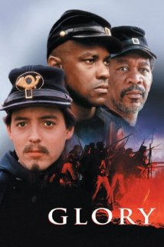

Thanks,
Valerie Cochara
valeriecochara@fordlandschools.org
Fordland Middle School

I hereby give __________________ my permission to watch the film Glory in US History class. (student name)

I do not give ____________________ my permission to watch the film Glory in US History class. (student name)

_________________________________________ Date ___________
Parent signature

